***NAME : Himanshu Dixit***

***ENROLL NO. : 21103262***

***BATCH : B10***

***Software Development fundamentals-2 [EVEN 2022]***

***Tutorial Sheet -1***

***1.*** *Write a C++ program to read a number and display it as an even or odd number.*

***Solution:***

#include<iostream>

using namespace std;

int main()

{

int num;

cout<<"Enter the Number :";

cin>>num;

if(num%2==0)

cout<<"Number is Even";

else

cout<<"Number is Odd";

return 0;

}

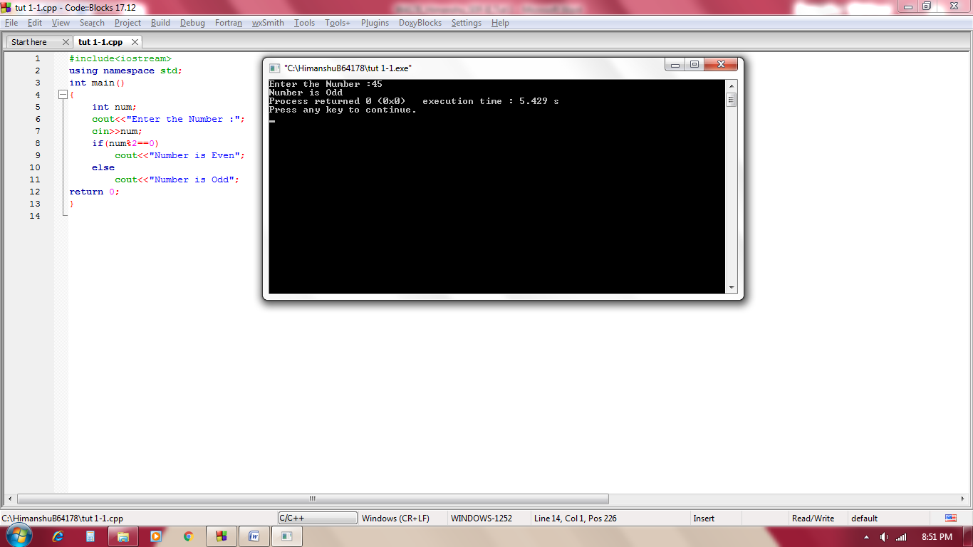

***2.*** *Write a C++ program to demonstrate various arithmetic operations.*

***Solution:***

#include<iostream>

using namespace std;

int main()

{

int num1,num2;

char ch;

cout<<"Enter the Numbers :";

cin>>num1>>num2;

cout<<"Addition is "<<num1+num2;

cout<<"\nSubtration is "<<num1-num2;

cout<<"\nMultiplication is "<<num1*num2;

cout<<"\nDivision is "<<num1/num2;

return 0;

}

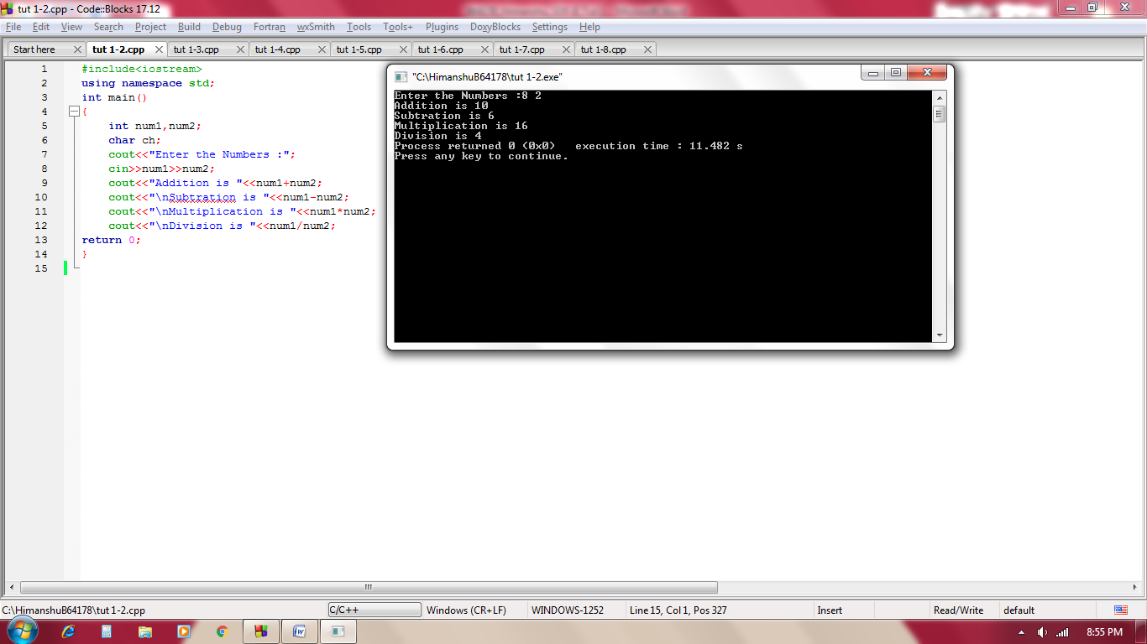

***3.*** *Write a C++ program to read two numbers x and y. Also, display its quotient and remainder on dividing x by y.*

***Solution:***

#include<iostream>

using namespace std;

int main()

{

int x,y;

cout<<"Enter the Numbers :";

cin>>x>>y;

cout<<"Quotient is "<<x/y;

cout<<"\nRemainder is "<<x%y;

return 0;

}

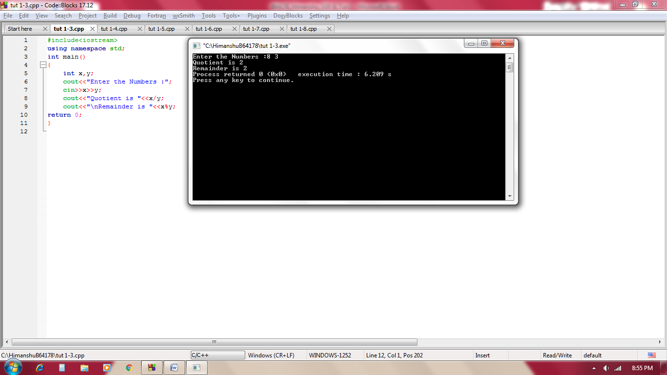

***4.*** *Write a C++ program to read a 3-digit number and reverse it.*

***Solution:***

#include<iostream>

using namespace std;

int main()

{

int num,rev=0;

cout<<"Enter the Number :";

cin>>num;

while(num>0)

{

int a=num%10;

rev=rev*10+a;

num=num/10;

}

cout<<"Reverse number is :"<<rev;

return 0;

}

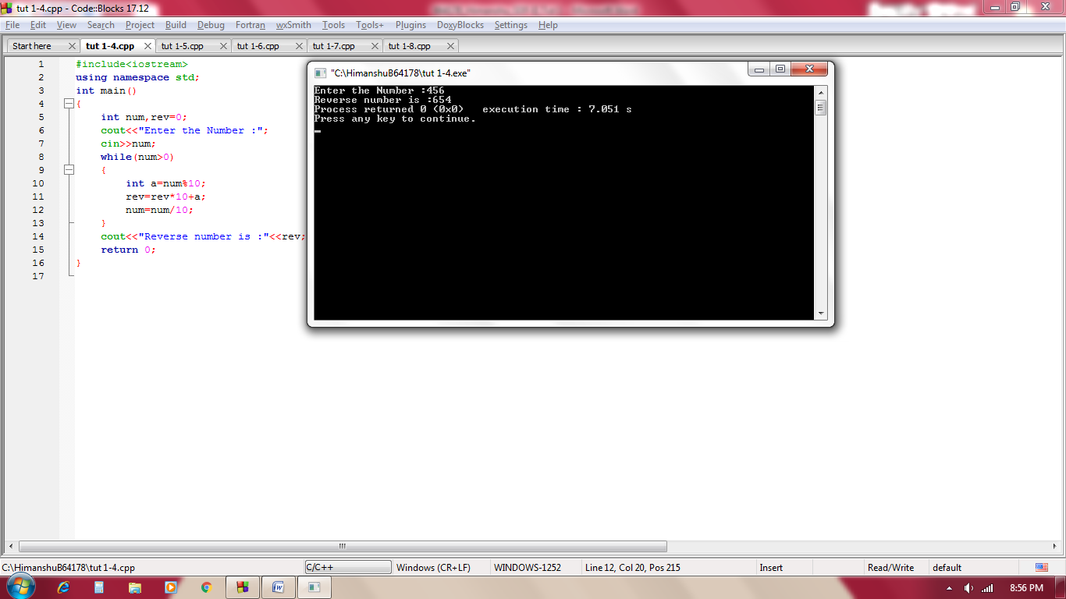

***5.*** *Write a C++ program to display the truth table of AND, OR, and NOT operators.*

***Solution:***

#include<iostream>

using namespace std;

int main()

{

cout<<"Truth table of AND :\n\n";

cout<<"p\tq\tp&q";

cout<<"\n-------------------";

cout<<"\n0\t0\t0\n0\t1\t0\n1\t0\t0\n1\t1\t1";

cout<<"\n\nTruth table of OR :\n\n";

cout<<"p\tq\tp|q";

cout<<"\n-------------------";

cout<<"\n0\t0\t0\n0\t1\t1\n1\t0\t1\n1\t1\t1";

cout<<"\n\nTruth table of NOT :\n\n";

cout<<"p\t-p";

cout<<"\n-------------------";

cout<<"\n0\t1\n1\t0";

return 0;

}

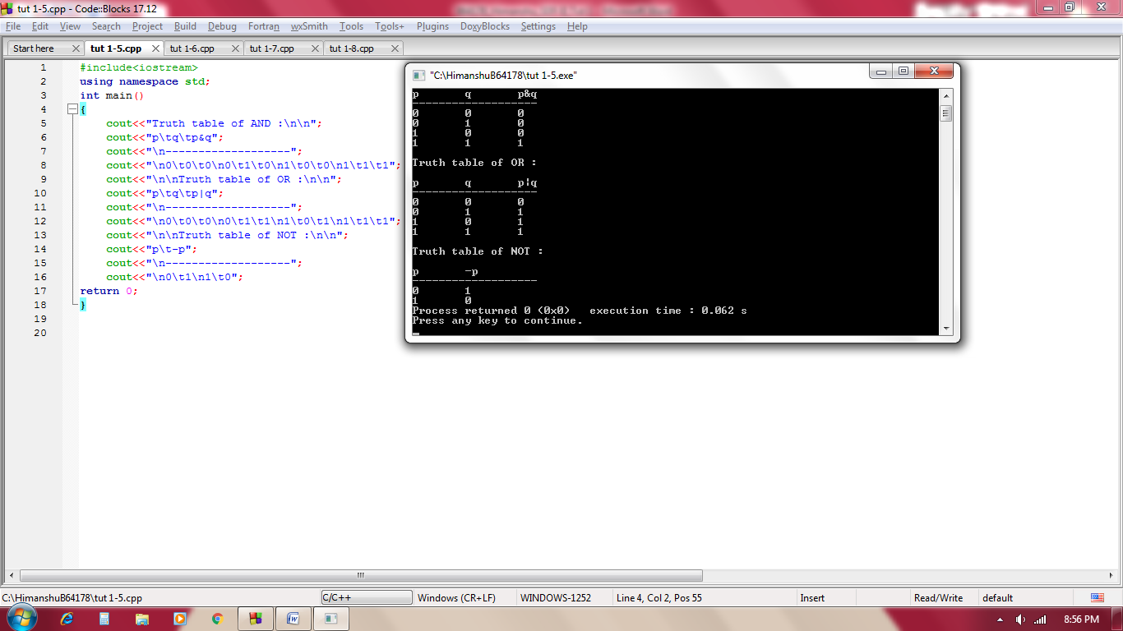

***6.*** *Write a C++ program to find the roots of a given quadratic expression.*

***Solution:***

#include<iostream>

#include<math.h>

using namespace std;

int main()

{

int a, b;

float c, d, z;

char I;

cout<<"Enter the values of a and b of complex number a+ib :";

cin>>a>>b;

z=sqrt(a*a + b*b);

cout<<"Square root of complex number is :";

c=sqrt((z+a)/2);

d=sqrt((z-a)/2);

if(b>0)

I='+';

else

I='-';

cout<<c<<" "<<I<<" i"<<d;

return 0;

}

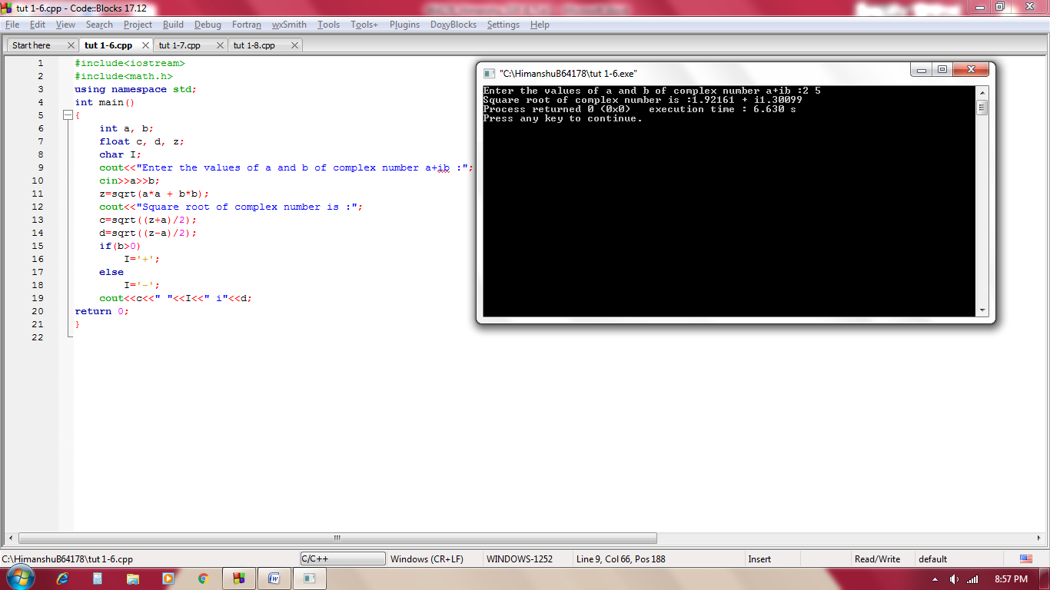

***7.*** *Write a C++ program to read a string and find the number of vowels in it.*

***Solution:***

#include<iostream>

#include<stdio.h>

using namespace std;

int main()

{

char a[100];

int count=0;

cout<<"Enter the string :";

gets(a);

for(int i=0;a[i]!='\0';i++)

{

if(a[i]=='a'||a[i]=='e'||a[i]=='i'||a[i]=='o'||a[i]=='u'||a[i]=='A'||a[i]=='E'||a[i]=='I'||a[i]=='O'||a[i]=='U')

count++;

}

cout<<"Total vowel is :"<<count;

return 0;

}

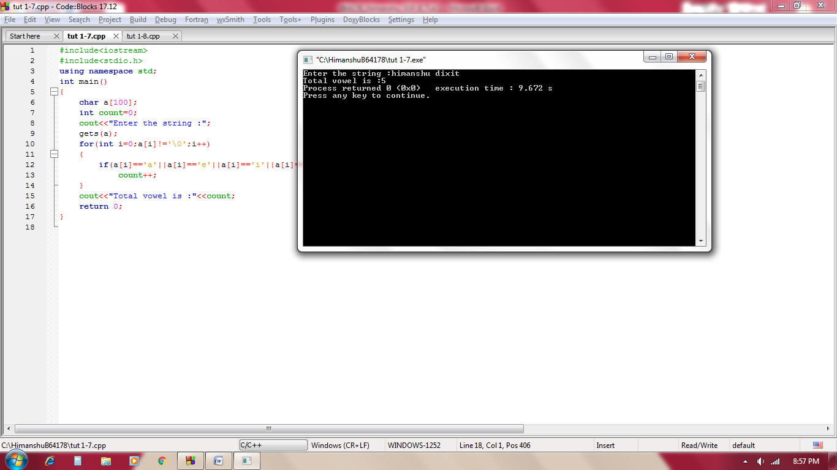

***8.*** *Write a C++ program to remove vowels from a given string.*

***Solution:***

#include<iostream>

#include<stdio.h>

using namespace std;

int main()

{

char a[100];

cout<<"Enter the string :";

gets(a);

for(int i=0; a[i]!='\0'; i++)

{

if(a[i]=='a'||a[i]=='e'||a[i]=='i'||a[i]=='o'||a[i]=='u'||a[i]=='A'||a[i]=='E'||a[i]=='I'||a[i]=='O'||a[i]=='U')

{

for(int k=i; a[k]!='\0'; k++)

{

a[k]=a[k+1];

}

i--;

}

}

cout<<"string after removing vowel is :";

puts(a);

return 0;

}

